**REPORT ON**

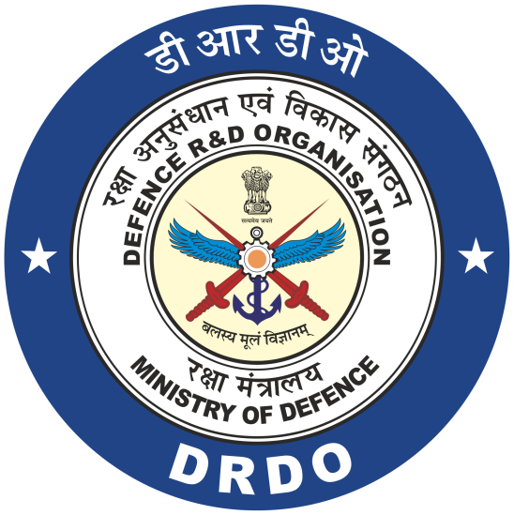

**MAIN BATTLE TANK (MBT)**

## Submitted by :

**PANKAJ BEHERA**

**BALASORE COLLEGE OF ENGINEERING AND TECHNOLOGY**

**COMPUTER SCIENCE**

**20_CSE_29**

**Undertaken at**

**PROOF & EXPERIMENTAL ESTABLISHMENT**

**DRDO**

**CHANDIPUR**

**INTRODUCTION**

Three decades after the first MBT-80 proof of concept vehicle was unveiled, five Arjun tanks, along with T 72 and T 90 tanks, will be handed over to the Army in June 2006. This batch constitutes the first delivery of the order of 124 tanks placed by the Indian Army. While flagging off the Bogie Flat Arjun Tank (BFAT) in Bangalore on 27 May 2006, Chief of Army Staff General JJ Singh said that the tanks were expected to be inducted into the Army after the field trials. The three decades that have gone into producing an MBT, that is acceptable to the Army, are dotted with adverse publicity. To begin with, the locally developed engine failed to perform to expectations.

This was followed by the unsatisfactory performance of the fire control system, that produced an erratic first hit rate ranging from 20-80 percent. Apart from its heavy weight, the tank was also larger than the tanks that can be transported by standard Indian railcars: it extends 6 cms beyond the allowed 3 cm on other side of the railcar. All this meant an extension of the project beyond the mandated timeframe and budget. Nevertheless, despite stinging criticism, the DRDO has finally managed to roll out a tank that started out as a MBT-80 but resulted in something equaling the top MBTs of the world – Abrahms, Leclerc and Leopard.

A comparison of the Arjun tank’s specifications, with the acclaimed MBTs and the best MBT in Indian possession (Bhishma), reveals that Arjun is not only on par with them, but better than them in firing capacity and battle survivability.

Three key factors adjudge the quality of any MBT. They are mobility, weapon systems, and battle survivability. Lets see how the Arjun fares.

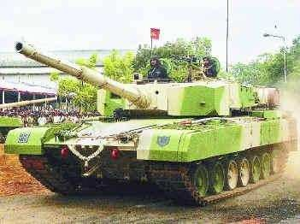

## MOBILITY

To begin with, though the weight of the tank if often cited as a failure, in actuality, the tank is not very heavy as compared to other tanks in its category. Despite its weight, it has very low ground pressure which will prevent the tank from ‘sinking in the sand’ as widely criticized. The M1A2, heavier than Arjun by more than

10 tons and with much higher ground pressure, performed remarkably well in the desert sands during the first Gulf War. The Arjun tank is not only more agile that the T-90S Bhishma, with a maximum speed of 72 km/h, but also exerts less ground pressure, thereby significantly reducing the chance of ‘sinking’.

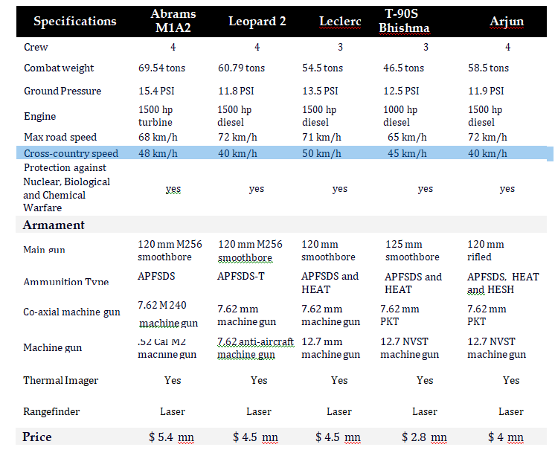DESIGN

The development of Arjun MBT began in March 1974. The tank heavily depends on foreign technology and equipment. German Leopard 2 tank developer Krauss Maffei provided the design assistance. Hence, the Arjun closely resembles Leopard 2A4 tank.

Between 25% and 30% of the tank components, including engine, transmission, gun barrel, tracks and fire control system, are imported.

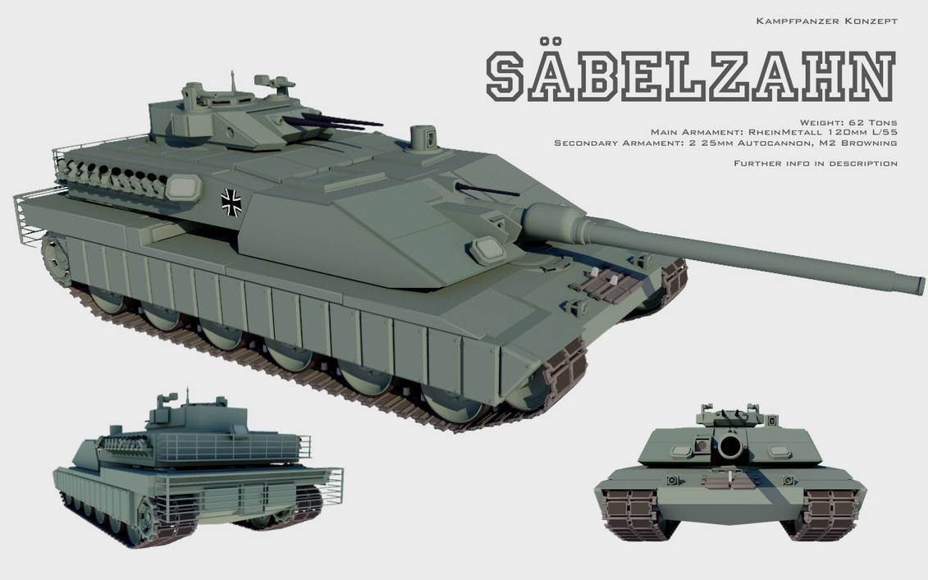

## ARMAMENT

The Arjun MBT is equipped with an indigenously developed 120mm main rifled gun with fin stabilised armour-piercing discarding sabot (FSAPDS) and high-explosive squash head (HESH) ammunition. An anti-personnel 7.62mm coaxial machine gun is fitted alongside the main gun and a 12.7mm machine gun is fitted at the top of the turret to aim aircraft and ground targets. An anti-helicopter round is also being developed to combat air threat to armour. The tank has special containers to carry 39 projectiles of 120mm [ammunition](https://www.army-technology.com/products/tank-ammunition/#mesko-sa). These containers keep the ammunition away from the crew, providing an additional level of survivability.

The rear-side faces of the turret are fitted with up to 12 smoke grenade dischargers. The weapon systems can be operated in silent watch mode using an auxiliary power unit.

## BATTLE SURVIVABILITY

The Arjun tank uses the indigenously designed and developed ‘Kanchan’ composite armor which is designed to provide protection superior to similar amour on other tanks. The ‘Kanchan’ amour has been successfully tested against fire from APFSDS, HEAT and HESH ammunitions. Experts who saw the MBT in the DEFEXPO 2004 did concede that the build appeared “much stronger that that of T-72 or T- 90S.”

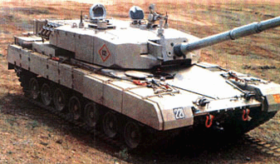

The integrated fire and explosion suppression system aboard Arjun is state-of-the-art technology with infra- red detectors, that can detect and suppress hydro-carbon fuel/explosion within 200 milliseconds in the crew compartment and within 15 seconds in the engine compartment. Arjun uses the Halon fire extinguishing system, similar to the one in the Abrams MBT, which can automatically activate within 2 milliseconds of either a flash or a fire. The tank also has protection against nuclear, biological and chemical weapons.

However, the specialty of the tank lies in its battlefield management system (BMS) which facilitates tactical command as well as control and communications between one tank and the rest of the team. A touch screen BMS for quick access, and an integrated Global Positioning System, enhances the efficiency of the tanks.

Like most tanks in this category, the Arjun tank also accommodates four crew members. While a three member crew with autoloaders could have increased the rate of fire from the currently 6-8 rounds/minute, a four member crew helps the crew to undertake more maintenance related work with less fatigue.

Finally, the indigenously developed hydro-pneumatic suspension provides excellent crew comfort that prevents fatigue despite extended runs.

Currently, more than 50 percent of the Arjun tank’s components are imported. According to the DRDO, this is likely to go down as production progresses. Few technological changes are also on the cards to increase operational capability.

In the final tally, the Arjun tank emerges as the best tank in India’s possession. Together with ‘Bhishma,’ the Arjun tank is set to form 30 percent of the state-of-the-art tanks that India plans to have. The discouraging developmental phase of the Arjun project not only discredited the capability of the DRDO to produce an MBT, but also gave rise to the skepticism that the purchase of the T- 90S from Russia was designed to kill the Arjun project. The successful completion of the Arjun project aims to put to rest these concerns. While the DRDO does deserve credit for the project, the army too could be given some credit, for it can be argued that if not for the uncompromising and scathing criticism from the Army, the Ajun would have ended up as an obsolete T-80 tank and not a state-of- the-art next generation tank.

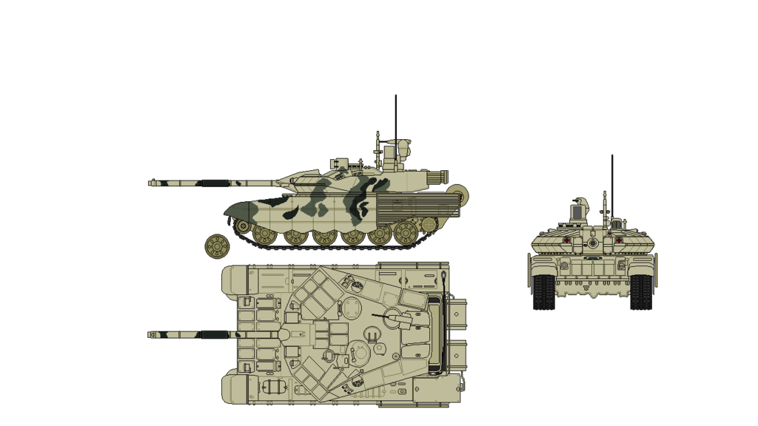

### SPECIFICATIONS

Dimensions

* Overall length {with gun forward) : 10.638 m
* Overall height {with gun rear) : 9.546 m
* Overall height {with AD gun mount) : 3.03 m(Turret roof: 2.32 m)
* Overall width : 3.864 m
* Combat weight : 58.5 tons

### TECHNICAL CHARACTERISTICS

* Max speed : 70 km/hr
* Max speed on cross country : 40 km/hr
* Ground pressure : 0.84 kg/sq. cm.
* Engine power : 1400 HP at 2400 rpm
* Engine characteristics: V 90° Turbo charged diesel, 10 cylinder water cooled
* Power-to-weight ratio :24:1 HP/ton
* Gear box : 4 fwd +2 rev gears Epicyclic gear train, Torque converter, Mech lockup clutch & hydrodynamic retARDEr
* Steering : Double radii, mechancial steering with neutral turn
* Suspension : Hydrogas
* Shallow fording: 1.4 m
* Vertical obstacle : 0.914 m
* Trench crossing : 2.43 m
* Gradient : 35 deg
* Gun : 120 mm rifled
* Rate of fire : 6-8 rounds per minute
* Ammunition : 39 rounds (FSAPDS/HESH)
* Co-axial machine gun : Mag 7.62 mm Tk 715 A
* Anti aircraft machine gun : HCB 12.7 mm
* Fire control system : Director type
* Gun control system : Electro-hydraulic
* Night vision : Thermal imaging
* Ballistic computer : Digital
* Crew : 4 (Cmdr, Gnr, Ldr. Dvr)

### SALIENT FEATURES

The superior armour defeating capability of the indigenously developed Fin Stabilized Armour Piercing Discarding Sabot (FSAPDS) ammunition and 120 mm calibre rifled gun give MBT ARJUN an edge over contemporary world tanks. A computer-controlled integrated fire control system incorporating day-cum-night stabilized sighting system guarantees a very high first round hit probability and reduced reaction time to bring effective fire on targets.

The stabilization system for the main armament, slaved to the sighting equipment in elevation and azimuth, with a high and accurate laying speed, allows fire on the move.

**The superior fire power of MBT is based on:**

The rifled 120 mm ARJUN gun together with the newly developed super velocity ammunition, can defeat any contemporary armour used in tanks. The electro-slag refined gun steel tube is autofrettaged to withstand higher gas pressures. A thermal jacket prevents irregular temperature distribution on to the tube due to the weather influences.

A co-axial 7.62 mm machine gun for anti-personnel and a 12.7 mm machine gun for anti-aircraft and ground targets are provided as secondary weapons.

Gunner's Main Sight consists of a day-sight, thermal sight, a laser range finder and a stabilized head common to all the three channels. The common sighting head mirror is stabilized in elevation and azimuth. The day- sight provides dual magnification.

The thermal imager provides night vision facility to the gunner and the commander to observe and engage target in total darkness and in the presence of smoke, dust, haze and light camouflage. Integral with the main sight is the laser range finder by which targets can be ranged accurately.

Commander's panoramic sight enables the commander to effect an all round surveillance in the battlefield without removing his eyes from the sight and without being disturbed by the turret motion. The field of view is stabilized with the help of a two axes rate gyro-mounted on the platform of the head mirror. The sight offers dual magnification.

## REFERENCES

1. “Main Battle Tank Arjun” at <http://www.drdo.com/products/> mbt.htm
2. <http://www.drdo.com/pub/techf> ocus/feb02/arjun.htm
3. <http://www.drdo.com/products/> mbt.htm
4. <http://www.drdo.com/pub/nl/> may2004/newdev.htm
5. <http://www.outlookindia.com/pt> i_news.asp?id=228516
6. [Main battle tank - Wikipedia](https://en.wikipedia.org/wiki/Main_battle_tank#Role)